Register No.

SRM INSTITUTE OF SCIENCE AND TECHNOLOGY
COLLEGE OF ENGINEERING & TECHNOLOGY
DEPARTMENT OF ELECTRONICS AND INSTRUMENTATION ENGINEERING
Cycle Test –II
Academic Year: 2025 - 26
________________________________________________________________________________________________________
Program offered: M.Tech Year / Sem: I/II
Course Title: CYBERSECURITY IN INDUSTRIAL AUTOMATION Max. Marks: 60
Course Code: 21EIE552T Duration: 2 Periods
Date of Exam:21/04/2026
_______________________________________________________________________________________________________
Course Articulation Matrix:
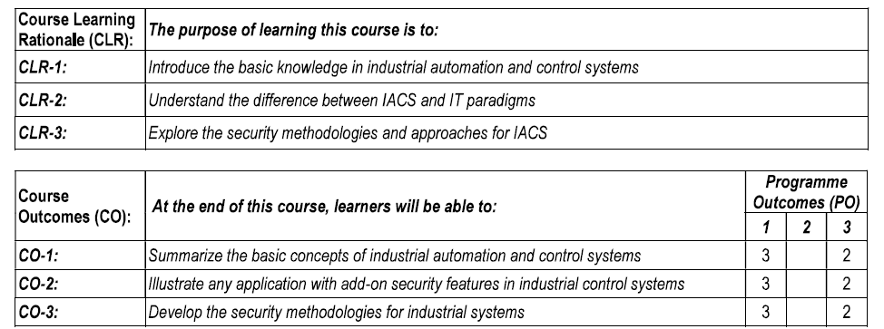
PART A
Answer ALL the questions
Sl.No | Question | Marks | CO | Blooms Level | PO | PI
1. | Explain the factors to be considered in adapting IT security methods to IACS. | 10 | 2 | 2 | 1 | 1.4.1
 | Describe the emerging technological trends and associated concerns that directly and indirectly affect the IACS landscape. | 10 | 2 | 2 | 1 | 1.4.1
 | (OR)
2. | Describe the important issues and common areas between IT and IACS. | 10 | 2 | 2 | 1 | 1.4.1
 | Describe the different types of threat sources and their driving factors in IACS. | 10 | 2 | 2 | 1 | 1.4.1

3. | Describe the NIST 800-39 integrated enterprise risk management system with neat sketch. | 10 | 3 | 2 | 1 | 1.4.1
 | Describe the working of cybersecurity management system of IACS. | 10 | 3 | 2 | 1 | 1.4.1
 | (OR)
4. | Describe the methodologies for risk management in IACS with neat sketch. | 10 | 3 | 2 | 1 | 1.4.1
 | Describe the cybersecurity lifecycle of a IACS with neat sketch. | 10 | 3 | 2 | 1 | 1.4.1

5. | Describe the effects of technological developements on IACS with smart grid as an example. | 10 | 2 | 2 | 1 | 1.4.1
 | Explain the NERC - Critical Infrastructure Protection(CIP) cybersecurity standards for enhancing the security of automation systems. | 10 | 3 | 2 | 1 | 1.4.1
 | (OR)
6. | Describe the technological issues related to the security posture of the smart grid system. | 10 | 2 | 2 | 1 | 1.4.1
 | Explain the NIST SP 800-82 OPERATIONAL CONTROL FOR IACS | 10 | 3 | 2 | 1 | 1.4.1

